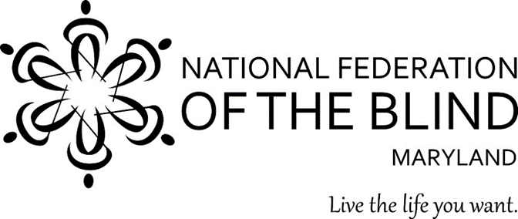

# Basket & Bag Bingo

**Featuring BASKETS AND BAGS from:**

**Longaberger, Kate Spade, Coach, Tory Burch, Marc Jacobs and more**!

## benefitting

### The National Federation of the

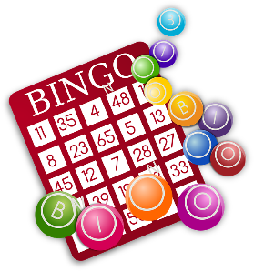 **Blind of Maryland**

## Friday, October 18, 2024

7:00 p.m. (Doors open at 6:00 p.m.)

The Lodge

2832 Nine Mile Circle

Catonsville, MD 21228

$25 per ticket before October 18*

$30.00 per ticket **on** October 18 (if available)

pay by Zelle ([President@nfbmd.org](mailto:President@nfbmd.org)), check made out to NFB of Maryland, or PayPal through https://nfbmd.org/bingo

Mail checks to: NFBMD, 1800 Johnson Street, Suite N1, Baltimore, MD 21230

**Over $4,000 in prizes!!! All baskets and bags filled!!!**

**Back by Popular Demand…Our Fabulous Pick-Your-Prize Raffle!**

**\*All ticket sales are final. *Seats must be claimed by 6:45 p.m. *For more information call 443-465-8761 or email Phippslatonya@gmail.com**